CHAPTER - 1
INTRODUCTION

OpenGL is an open specification for an applications program interface for defining 2D and 3D objects. The specification is cross-language, cross-platform API for writing applications that produce 2D and 3D computer graphics. It renders 3D objects to the screen, providing the same set of instructions on different computers and graphics adapters. Thus it allows us to write an application that can create the same effects in any operating system using any OpenGL-adhering graphics adapter.
Computer graphics, a 3-dimensional primitive can be anything from a single point to an n-sided polygon. From the software standpoint, primitives utilize the basic 3-dimensional rasterization algorithms such as Bresenham's line drawing algorithm, polygon scan line fill, texture mapping and so forth. OpenGL's basic operation is to accept primitives such as points, lines and polygons, and convert them into pixels. This is done by a graphics pipeline known as the OpenGL state machine. Most OpenGL commands either issue primitives to the graphics pipeline, or configure how the pipeline processes these primitives.
OpenGL is a low-level, procedural API, requiring the programmer to dictate the exact steps required to render a scene. OpenGL's low-level design requires programmers to have a good knowledge of the graphics pipeline, but also gives a certain amount of freedom to implement novel rendering algorithms.
2D COMPUTER GRAPHICS: It is the computer based generation of digital images from two dimensional images, text to be typeset mathematical function and equation and more. These components can be modified and manipulated by two-dimensional geometric transformation such as translation, rotation, scaling etc. Text shapes and lines are rendered with a client specified color many libraries and cards provide color gradients.
Which are hands for the generation of smoothly varying background, shadow effects etc. painting a pixel with a given color usually replaces its previous color. Many systems supports painting with transparent colors which only as inverting color or color inversions.
ADVANTAGE OF OPENGL
- with different 3D accelerators, by presenting the programmer To hide the complexities of interfacing with a single, uniform API.
- To hide the differing capabilities of hardware platforms, by requiring that all implementations support the full OpenGL feature set (using software emulation if necessary).

CHAPTER - 2
SYSTEM SPECIFICATION

2.1 HARDWARE REQUIREMENT
The hardware requirements are very minimal and the software can run on most of the machines.
- Processor - Intel 486/Pentium processor or above.
- Processor Speed - 500 MHz or above
- RAM - 64MB or above Storage Space - 2 MB or above
- Monitor resolution - A color monitor with a minimum resolution of 640*480
- Mouse
- Keyboard

2.2 SOFTWARE REQUIREMENT
- An MS-DOS based operating
- system like Windows 98, Windows 2000 or Windows XP is the platform required to develop the 2D and 3D graphics applications.
- A Visual C/C++ compiler is required for compiling the source code to make the executable file which can then be directly
- executed.
- A built in graphics library like glut and glut32, and header file like glut.h and also dynamic link libraries like glut and glut32 are required for creating the 3D layout.

CHAPTER 3
SOFTWARE DESCRIPTIONS

3.1 FRONT END
Front-end loading is including robust planning and design early in a project's lifecycle (i.e., the front end of a project), at a time when the ability to influence changes in design is relatively high and the cost to make those changes is relatively low.The front we used in the project is Open GL software.

3.1.1 What Is OpenGL?
OpenGL is a software interface to graphics hardware. OpenGL is a low-level graphics library specification. It makes available to the programmer a small set of geometric primitives - points, lines, polygons, images, and bitmaps.
OpenGL provides a set of commands that allow the specification of geometric objects in two or three dimensions, using the provided primitives, together with commands that control how these objects are rendered (drawn). Since OpenGL drawing commands are limited to those that generate simple geometric primitives (points, lines, and polygons), the OpenGL Utility Toolkit (GLUT) has been created to aid in the development of more complicated three-dimensional objects such as a sphere, a torus, and even a teapot.
3.1.2 The OpenGL Utility Library
The OpenGL Utility Library, or GLU, supplements OpenGL by providing higher-level functions. GLU offers features that range from simple wrappers around OpenGL functions to complex components supporting advanced rendering techniques. Its features include
- 2D image scaling.
- Rendering 3D objects including spheres, cylinders, and disks.
- Automatic mipmap generation from a single image.
- Support for curves surfaces through NURBS.
- Support for tessellation of non-convex polygons.
- Special-purpose transformations and matrices
3.1.3 What Is GLUT?
GLUT, short for OpenGL Utility Toolkit, is a set of support libraries available on every major platform. OpenGL does not directly support any form of windowing, menus, or input. That's where GLUT comes in. It provides basic functionality in all of those areas, while remaining platform independent, so that you can easily move GLUT-based applications from, for example, Windows to UNIX with few, if any, changes.GLUT is easy to use and learn, and although it does not provide you with all the functionality the operating system offers, it works quite well for demos and simple applications.

3.1.4 GL State
The GL maintains considerable state. This document enumerates each state variable and describes how each variable can be changed. For purposes of discussion, state variables are categorized somewhat arbitrarily by their function. Although we describe the operations that the GL performs on the frame buffer, the frame buffer is not a part of GL state. While an implementation of the GL may be hardware dependent.

3.1.5 OpenGL History
OpenGL was originally developed by Silicon Graphics, Inc. (SGI) as a multi-purpose, platform-independent graphics API. Since 1992, the development of OpenGL has been overseen by the OpenGL Architecture Review Board (ARB), which is made up of major graphics vendors and other industry leaders, currently consisting of ATI, Compaq, Evans & Sutherland, Hewlett- Packard, IBM, Intel, Intergraph, nVidia, Microsoft, and Silicon Graphics.
Because OpenGL is designed to be used with high-end graphics workstations, it has, until recently, included the power to take full advantage of consumer-level graphics hardware. Furious competition over the last couple of years, however, has brought features once available only on graphics workstations to the consumer level; as a result, there are more and more video cards of which OpenGL can't take full advantage. Eventually, these extensions may become official additions to the OpenGL standard. OpenGL 1.2 was the first version to contain support for features specifically requested by game developers (such as multitexturing), and it is likely that future releases will be influenced by gaming as well.
3.1.6 Advantages of OpenGL
- With different 3D accelerators, by presenting the programmer to hide the complexities of interfacing with a single, uniform API.
- To hide the differing capabilities of hardware platforms, by requiring that all implementations support the full OpenGL feature set (using software emulation if necessary)

3.2 FEATURES
- OpenGL is designed as a streamland, hardware independent interface to be implemented on many different hardware platforms.
- to achieve this qualities , no commands for performing windowing task or obtaining user input are included in OpenGL.
- With OpenGL , you must build-up your desired model from a small set of geometric primitives, points, lines and polygons.
- A sophasticated library(GLU) provides many of the modeling features,such as quadrid surfaces and NURBS curves and surfaces.
- GLU is a standard part of OpenGL implementation.
- What an OpenGL doesn’t do? Here what is to do.OpenGL command syntax.
- OpenGL commands use the prefix gl and initial capital letters for each word making up the command name

CHAPTER 4
PROJECT DESCRIPTION

4.1 Overview of the Project

Purpose
This Project is on the Implementation Of 3D shapes in Computer graphics using OpenGL Functions.
In the “3D-Shapes” implementation we mainly used the concepts of polygons to build different geometric objects and for the movement we used OpenGL functions for Translation and Rotation.
We used the mouse interface for geometric objects to translate and rotate around 360 degree. Light functions are used for viewing the geometric objects as almost as a real object. We make use of OpenGL for whole coding purpose. The OpenGL Utility Toolkit is a Programming Interface for writing OpenGL programs. The Toolkit supports much functionality like multiple window rendering, callback event driven processing, sophisticated input devices etc. There are many types of three-dimensional shapes.

OpenGL Functions

Major graphics operations which OpenGL performs to render an image on the screen:
- Construct shapes from geometric primitives, thereby creating mathematical descriptions of objects.
- Arrange the objects in three-dimensional space and select the desired vantage point for viewing the composed scene.
- Calculate the color of all the objects. The color might be explicitly assigned by the application, determined from specified lighting conditions, obtained by pasting a texture onto the objects, or some combination of these three actions.
- Convert the mathematical description of objects and their associated color information to pixels on the screen. This process is called Rasterization.

The OpenGL library functions used for our project along with their descriptions as mentioned below:

- glVertex [234][sifd](TYPE Xco-ordinate, TYPE Yco-ordinate, TYPE Zco-ordinate.)
This is used to specify the position of a vertex in 3D.
- glBegin(glEnum mode)
This initiates a new primitive of type mode and starts the collection of vertices. Values of mode include GL_POINTS, GL_TRIANGLES, GL_POLYGON and GL_LINES.
- glEnd()
Terminates a list of vertices.
- glMaterial[if](GLenum face, GLenum parm, TYPE value)
This sets parm for face (GL_FRONT, GL_BACK,GL_FRONT_ AND_ BACK);
- glClearColor(GLclampf r, GLclampf g, GLclampf b, GLclampf a)
This sets the present RGB color used when clearing the color buffer.
- glSwapBuffers()
Swaps the front and back buffers.
- glRotatef(angle,vx,vy,vz)
This is used to rotate an object in the specified angle in degrees and vx,vy,vz are the components of a vector about which we wish to rotate.
- glPushMatrix() and glPopMatrix()
They are used to push the transformation matrix on to the stack and to recover later the original condition respectively.
- glTranslatef(dx,dy,dz)
This is used to displace an object by a fixed distance in a given direction. dx,dy,dz are the components of the displacement vector.
- glEnable(GL_DEPTH_TEST)
It allows algorithm to store the information in the DEPTH buffer.
- glMatrixMode(GLenum mode)
Specifies which matrix will be affected by subsequent transformations. Mode can be GL_MODELVIEW, GL_PROJECTION, or GL_TEXTURE.
- glutPostRedisplay()
Requests that the display callback be executed after the current callback returns.
- glLoadIdentity()
Sets the current transformation matrix to an identity matrix.
- glutMainLoop ()
Cause the program to enter an event processing loop. It should be the last statement in main.

4.2 MODULE DESCRIPTION

Rotation
The act of rotating;,rotary motion 2. a regular cycle of events in a set order or sequence 3. a planned sequence of cropping according to which the crops grown in successive seasons on the same land are varied so as to make a balanced demand on its resources of fertility
Module may contain a documentation comment before the module header, in which case this comment is interpreted by Haddock as an overall description of the module itself, and placed in a section entitled “Description” in the documentation for the module
In linear algebra a rotation matrix is a matrix that is used to perform a rotation in Euclidean space. For example the matrix
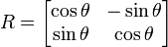
- The fig shows rotation about a fixed point
Before After
. 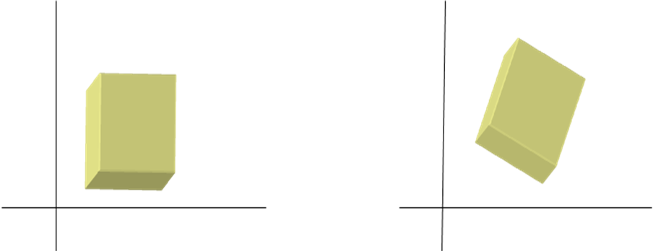
FIG 4.2.1

Translation

It is moving every point a constant distance in a specified direction. It is one of the motions other rigid motions include rotation and reflection). A translation can also be interpreted as the addition of a constant vector to every point, or as shifting the origin of the coordinate system. A translation operator is an operator such that

Since a translation is an affine transformation but not a linear transformation,are normally used to represent the translation operator by a matrix and thus to make it linear. Thus we write the 3-dimensional vector w = (w_{x}, w_{y}, w_{z}) using 4 homogeneous coordinates as w = (w_{x}, w_{y}, w_{z}, 1).
To translate an object by a vector v, each homogeneous vector p (written in homogeneous coordinates) would need to be multiplied by this translation matrix
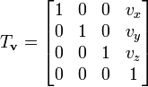

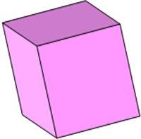

FIG 4.2.2

Scaling

A scaling can be represented by a scaling matrix. To scale an object by a vector v = (v_{x}, v_{y}, v_{z}), each point p = (p_{x}, p_{y}, p_{z}) would need to be multiplied with this scaling matrix:
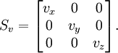

Non-Uniform scaling

Uniform scaling

FIG 4.2.3

4.3 DATAFLOW DIAGRAM

The flow diagram below shows the various functions involved in the design of the implementation of 3d shapes .it shows the transfer of control from one function to other. the output of the program can be in the following ways
- Cone
- cube
- Tetrahedron
- Sphere
- Octahedron
- Rotation of all the objects
- Change in the color of the objects

Input using events

Cube, cone,tetrahedron,octahedron,sphere

select the object
rotate
select the color

output

4.4 INPUT DESIGN

Input devices are used to provide input to the user application.ther are three modes in which the input devices can provide input to the application program such as
- Request mode:in this mode the measure of the device is not given until the device is triggered
- Sample mode:in this mode the input is immediate
- Event mode:this mode is used when there are variety of input devices

The data that the input devices gives to the application program is called as the measure and the time instance at which the data is sent by the device to the program is called as the trigger
Example1:the measure of the keyboard is a single character or the array of character whereas the trigger is entry key

4.5 OUTPUT DESIGN
3D Modeling
- 3D modeling is computer graphics that use a three-dimensional representation of geometric data that is stored in the computer for the purpose of performing calculations and rendering 2D images. Such images may be for later display or for real-time viewing.
Transformations
The transformations like translations, scaling, rotation and reflections are implemented. The sequences of operations are:
- Select an area using select tool.
- Select the transformation mode. The selected area is copied into an array.
- From the popup menu select required transformations such as translation, rotation, scaling and reflection.
- After performing transformation select draw mode from mode menu.
- We can derive the matrices for rotation about x and y-axes through identical argument. If we rotate about x-axis then x values are unchanged similarly if we rotate about y and z-axes those values are unchanged

CHAPTER- 5
CONCLUSION & FUTURE ENHANCEMENTS
We started with modest aim with no prior experience in any programming projects as this, but ended up in learning many things, fine tuning the programming skills and getting into the real world of software development with an exposure to corporate environment. During the development of any software of significant utility, we are forced with the tradeoff between speed of execution and amount of memory consumed. This is simple interactive application. It is extremely user friendly and has the features, which makes simple graphics project. It has an open source and no security features has been included. The user is free to alter the code for feature enhancement. Checking and verification of all possible types of the functions are taken care. Care was taken to avoid bugs. Bugs may be reported to creator as the need.

- Providing more users friendly.
- To provide lightning functions to view like a real world object.
- We can further implement this project to develop animations.

APPENDIX
SCREENSHOTS
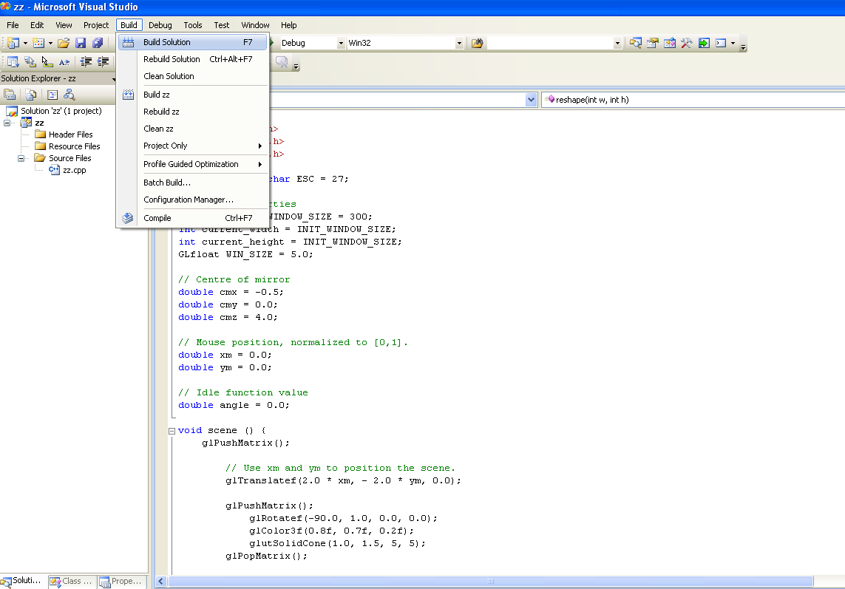

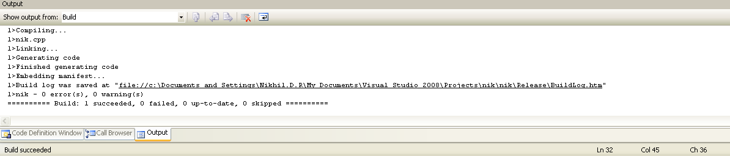
Fig 7.2.1

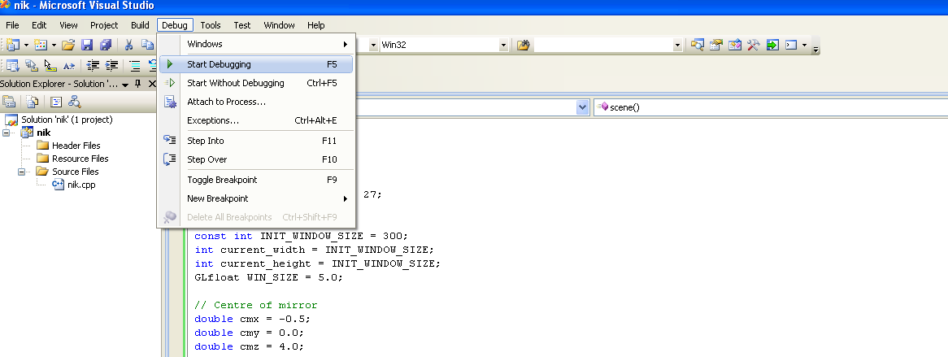

Fig 7.2.2

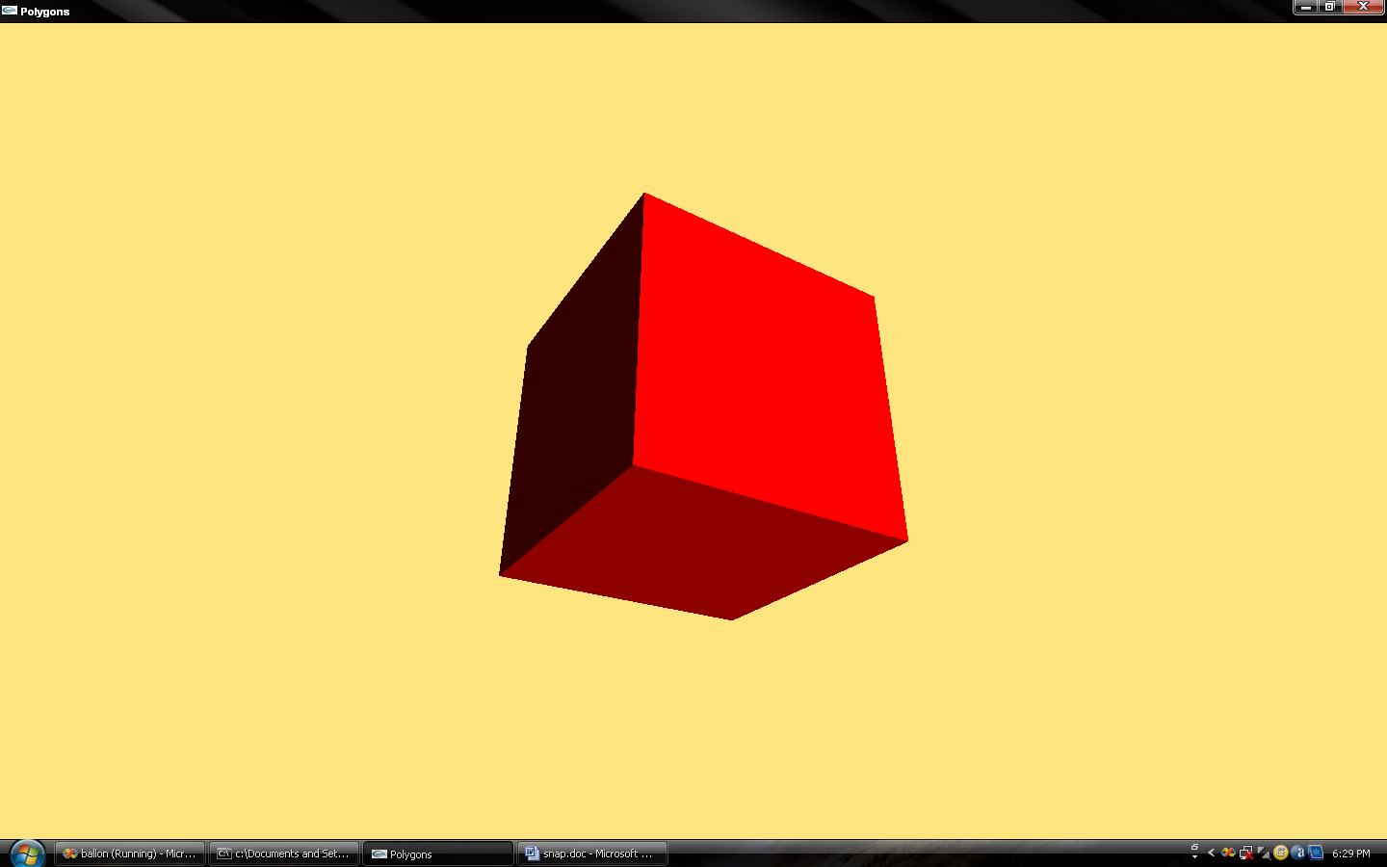

Fig 7.2.3
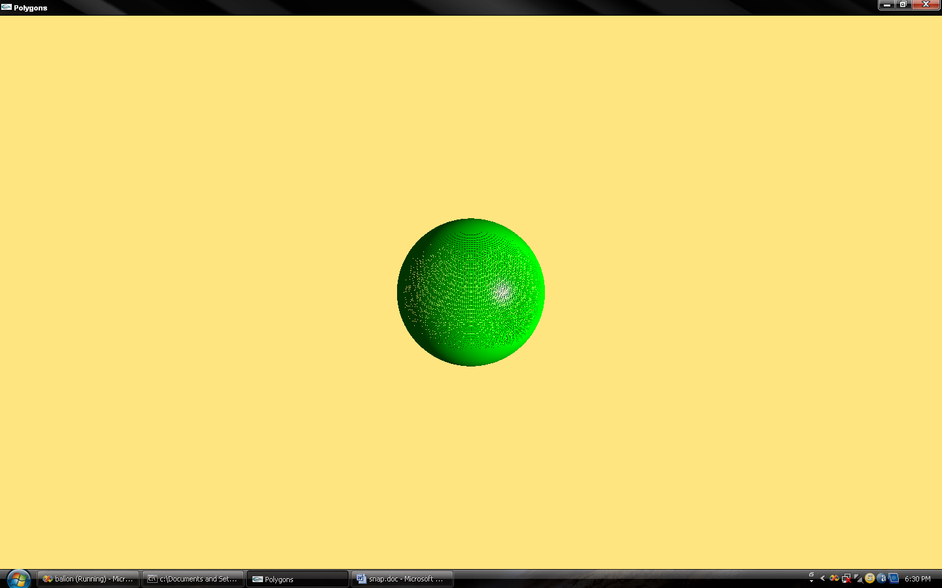

Fig 7.2.4

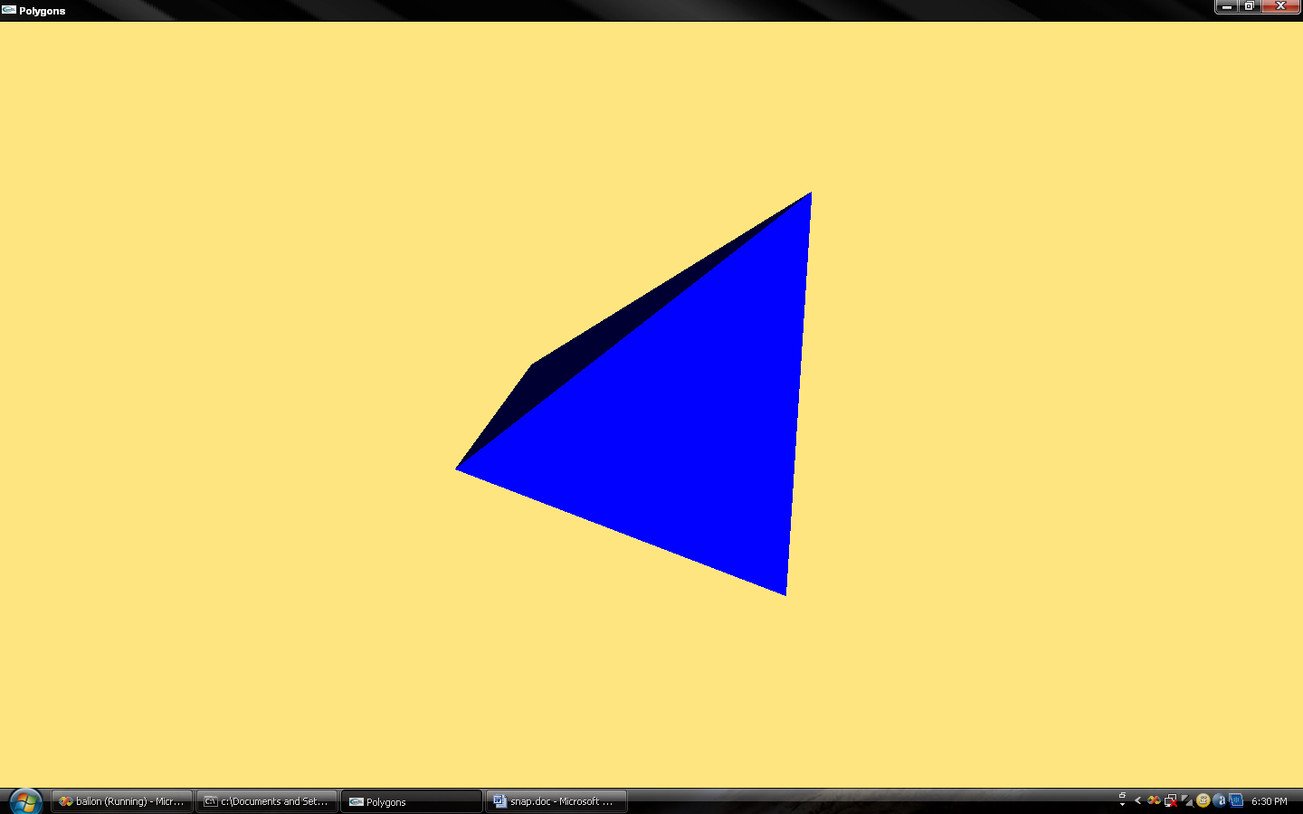

Fig 7.2.5

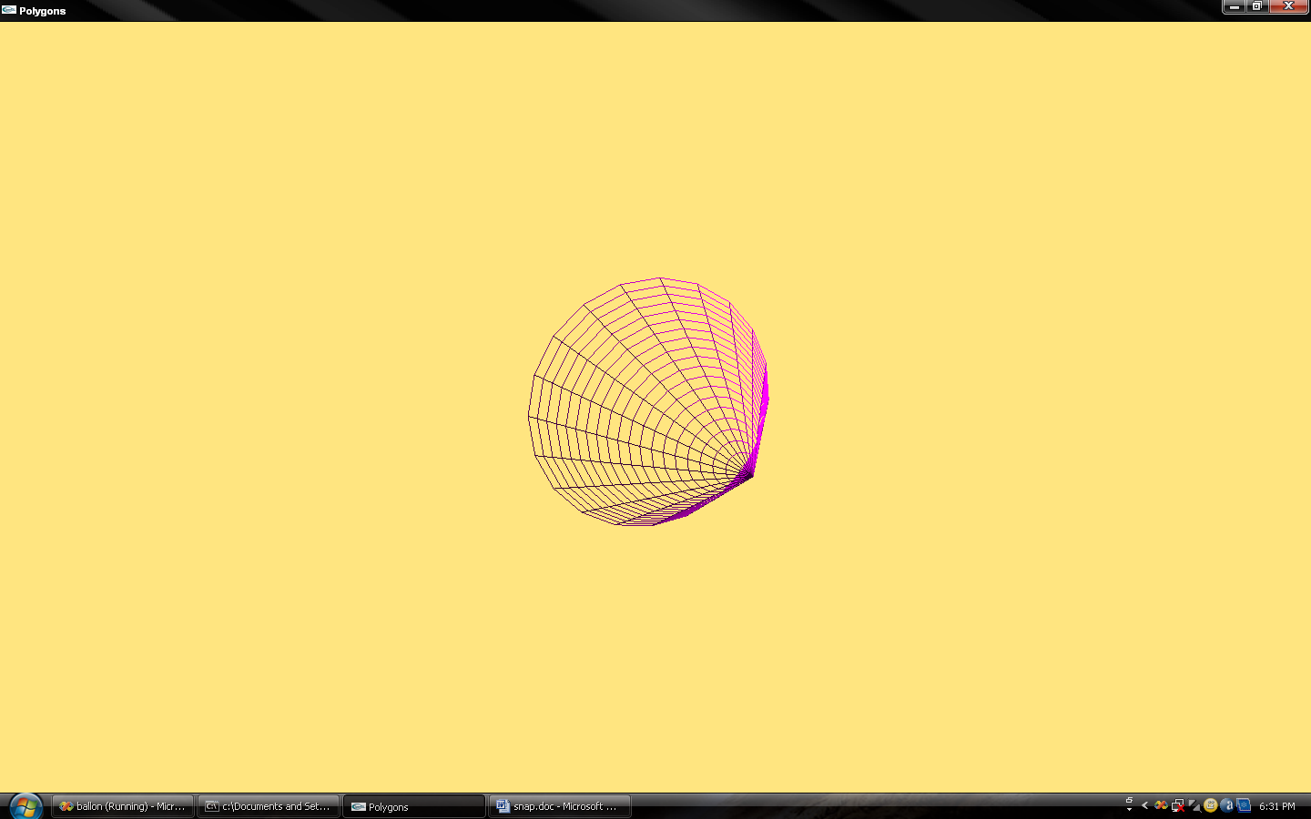

Fig 7.2.6

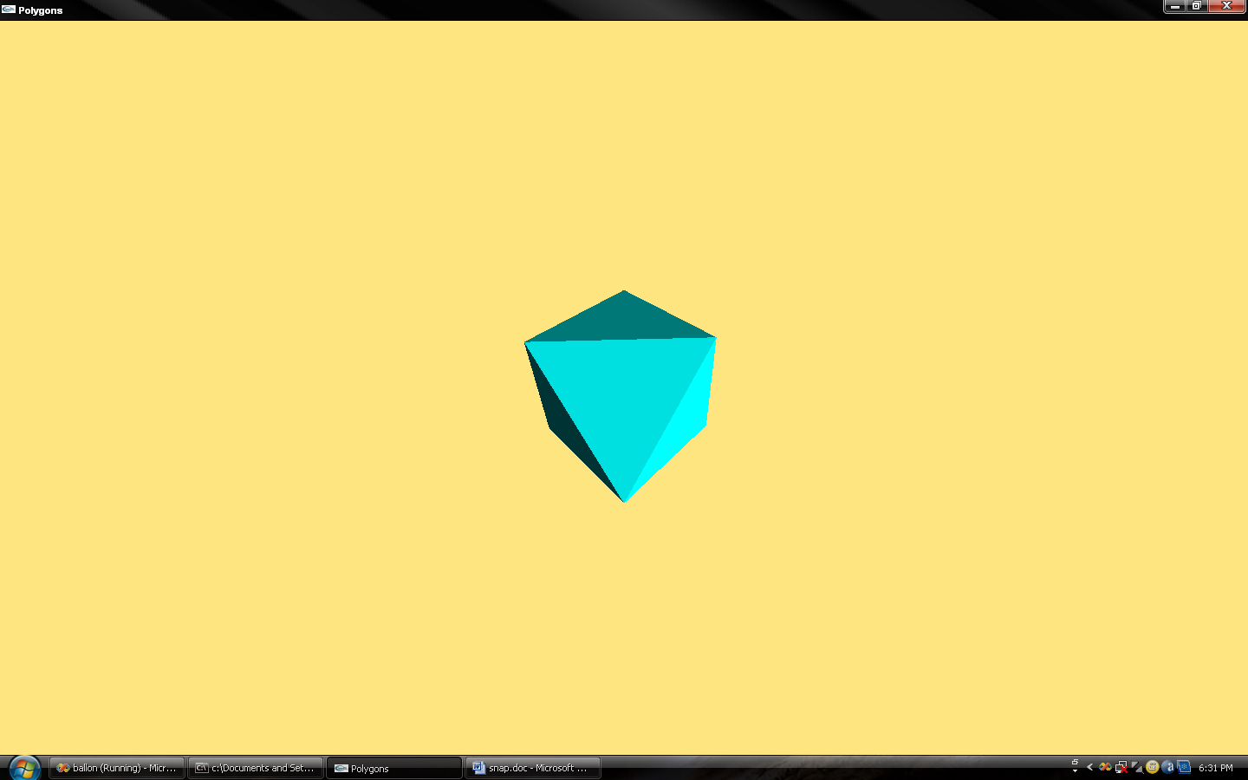
Fig 7.2.7

REFERENCES
Reference Books and E-books

- EDWARD ANGEL: interactive computer graphics, 5th edition, universities of New Mexico.
- [1996] Foley Et. al 2nd Edition, Computer Graphics principles & practice - This is one comprehensive book for understanding the computer graphics concepts. Information regarding the 2D transformations has been taken from this book.
- Donald Hearn and touline baker computer graphics c version.2nd edition Pearson education 2003.

Websites for REFERENCE
- www.opengl.org/resources/code/samples/redbook/
- www.wikipedia.org

